LEARNING EXPERIENCE JOURNAL

Student Name : Flores Harvey Ross, Leaban
Student Course : Bachelor of Science in Computer Science
Student Number : 20230112023
Company name : DevSupreme Solution Incorporation
Division/Unit Assigned : I.T. Department

The trainee should give a brief and concise report of the task performed during the training and how it was accomplished. This report should indicate the machineries, equipment, facilities, tools and materials used if any. This report should be accomplished daily and this should be submitted every week to their Practicum adviser.

Day |  | Accomplishment | Documentation
1 | Date: July 8, 2026  Time In: 9:00 A.M.  Time Out: 6:00 P.M.  Hours Accumulated: 8 | We were given a project to work on the Warehouse Management System (WMS). I began by exploring its initial setup and getting hands-on practice in building a WMS from the ground up. Using Base44, I revised and refined the user interface to serve as a clear, simple reference point for the system's overall appearance, structure, and ease of use. | 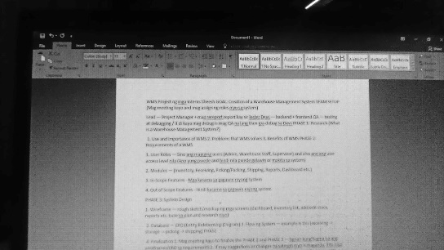
2 | Date: July 9, 2026  Time In: 9:00 A.M.  Time Out: 6:00 P.M.  Hours Accumulated: 8 | We continued working on the project, making adjustments to the different modules of our Warehouse Management System. I checked each module to keep the layout and design consistent. I also made small improvements to the navigation to make the interface easier to use. | 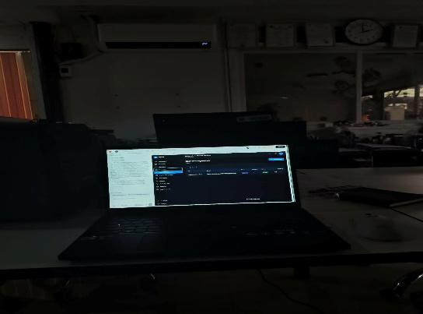

16 Hours
Total Number of Hours Worked:
Certified by:

_____________________
Name Trainer/Immediate Supervisor

